|  |
| --- |
| **SUPER BOWL LX**  THE OFFICIAL GAME RECAP  **SEATTLE SEAHAWKS 29 - 13 NEW ENGLAND PATRIOTS**  February 8, 2026 | Levi's Stadium, Santa Clara, CA |

# **EVENT OVERVIEW**

Super Bowl LX delivered one of the most dominant defensive performances in championship history as the Seattle Seahawks dismantled the New England Patriots 29-13 at Levi's Stadium in Santa Clara, California on February 8, 2026. An estimated 75,000+ fans packed the venue to witness Seattle claim the second Lombardi Trophy in franchise history.

The NFC champion Seahawks, who finished the 2025 season with a dominant 14-3 record under second-year head coach Mike Macdonald, channeled the spirit of the legendary 'Legion of Boom' era with a suffocating defense that held New England scoreless through three quarters.

|  |  |  |  |
| --- | --- | --- | --- |
| **FINAL SCORE**  **29-13** | **ATTENDANCE**  **75,000+** | **SACKS ON MAYE**  **5** | **ECONOMIC IMPACT**  **$630M** |

**Historic Fact:** The Patriots became the first team to go scoreless through three quarters in a Super Bowl since the Minnesota Vikings in Super Bowl VIII (1974). Drake Maye: 8/18, 61 yards, 5 sacks.

# **THE MATCHUP**

|  |  |  |
| --- | --- | --- |
| **SEATTLE SEAHAWKS** | **VS** | **NEW ENGLAND PATRIOTS** |
| 14-3 | **RECORD** | 11-6 |
| 1st NFC | **SEED** | 4th AFC |
| Mike Macdonald | **HEAD COACH** | Mike Vrabel |
| Sam Darnold | **QUARTERBACK** | Drake Maye |
| Kenneth Walker III | **KEY PLAYER** | Drake Maye |
| #1 Scoring Defense | **DEFENSE** | #12 Scoring Defense |
| 29 | **FINAL SCORE** | 13 |

# **GAME HIGHLIGHTS**

## **FIRST QUARTER**

The Seahawks set the tone with Kenneth Walker III gashing the defense for 94 first-half rushing yards. Seattle's defense held New England to minimal yardage. Quarter ended 3-0 Seahawks.

## **SECOND QUARTER**

Seattle continued building momentum. By halftime, Walker had 100 of Seattle's 183 total yards. Drake Maye struggled against the relentless pass rush.

## **THIRD QUARTER**

The defensive masterclass continued - Patriots remained scoreless through three full quarters. Seattle's pass rush recorded multiple sacks, extending the lead.

## **FOURTH QUARTER**

The floodgates opened. A.J. Barner caught a 16-yard TD from Darnold (19-0). Nwosu and Love each grabbed interceptions. Witherspoon forced a fumble, Nwosu scooped it for a 45-yard TD. Patriots scored 13 late. Final: 29-13.

*“This defense carried us all year. Tonight was the culmination of everything we built together.”*

— Mike Macdonald, Head Coach

# **MVP SPOTLIGHT**

**KENNETH WALKER III**

Running Back | Seattle Seahawks | Super Bowl LX MVP

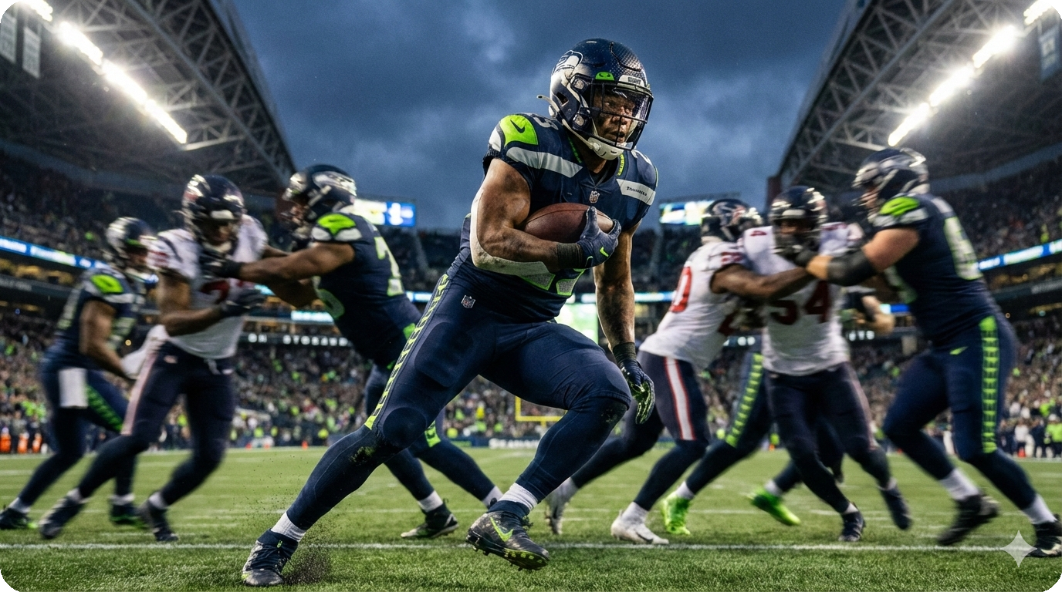

|  |  |  |  |
| --- | --- | --- | --- |
| **RUSH YARDS**  **135** | **CARRIES**  **27** | **RECEPTIONS**  **2 for 26** | **SCRIMMAGE YDS**  **161** |

Kenneth Walker III: 135 yards on 27 carries, 2 catches for 26 yards, 161 total scrimmage yards. His 94 first-half rushing yards were the second-most in Super Bowl history.

**Making History:** Walker became the first RB to win Super Bowl MVP since Terrell Davis in XXXII (1998). His 135 rushing yards were the most since Davis' 157 nearly 30 years ago. His father attended his first-ever NFL game to see his son earn MVP honors.

# **KEY PLAYERS**

## **SEATTLE SEAHAWKS**

**Sam Darnold, QB** Greatest redemption arc in NFL history. Once a 'bust' after being #3 pick in 2018, Darnold led Seattle to a Lombardi Trophy.

**Uchenna Nwosu, LB** Interception + 45-yard fumble return TD that sealed the game.

**Devon Witherspoon, CB** Play of the game: blitzed Maye, forced the fumble for Nwosu's scoop-and-score.

**Julian Love, S** Added an interception in the fourth quarter.

**A.J. Barner, TE** First offensive TD: 16-yard catch from Darnold.

## **NEW ENGLAND PATRIOTS**

**Drake Maye, QB** Tough night: 8/18, 61 yards, 5 sacks. But reaching the Super Bowl in year two is remarkable.

# **HALFTIME SHOW**

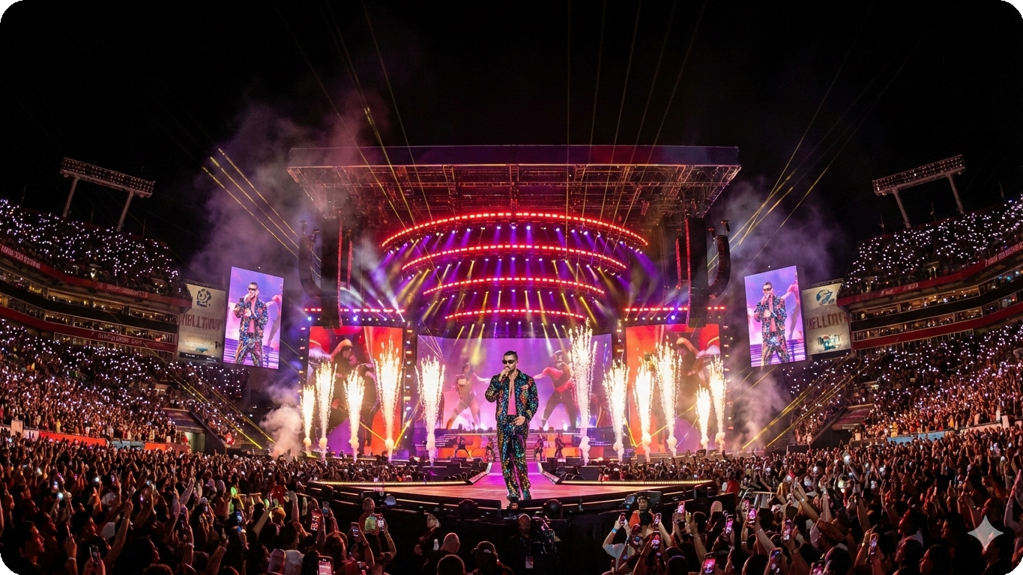

Bad Bunny delivered a historic, nearly 14-minute performance - the first-ever primarily Spanish-language Super Bowl halftime show. The Puerto Rican superstar electrified 75,000+ fans with high-energy Latin music on the world's biggest stage.

## **SETLIST HIGHLIGHTS**

|  |  |
| --- | --- |
| **Opening** | Titi Me Pregunto |
| **Fan Favorite** | Yo Perreo Sola |
| **Cultural Anthem** | VOY A LLeVARTE PA PR |
| **With Lady Gaga** | Die With a Smile (Spanish remix) |

**Special Guests:** Lady Gaga (third Super Bowl halftime appearance), Ricky Martin, Karol G, Pedro Pascal, Jessica Alba, and Cardi B all appeared during the set.

# **HISTORICAL CONTEXT**

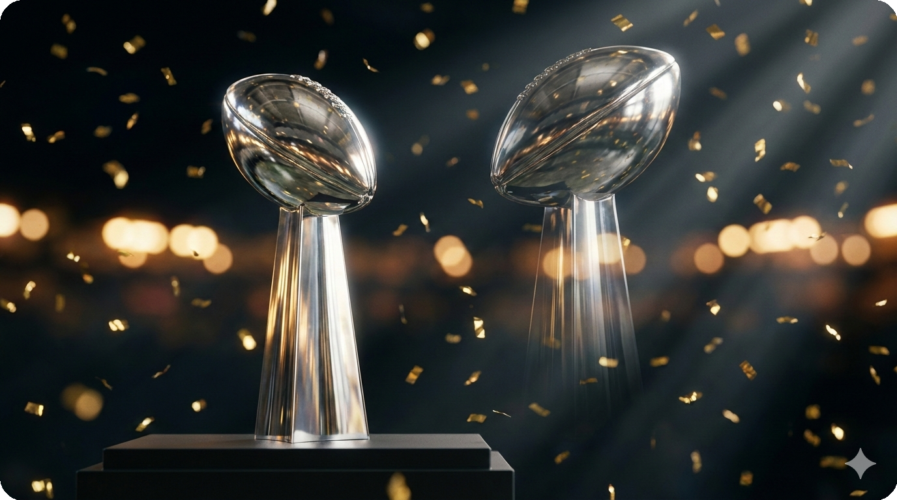

Super Bowl LX marked the Seahawks' second championship, following the same defensive-dominance formula that won Super Bowl XLVIII in 2014 with the 'Legion of Boom.' A dozen years later, a new generation etched their names alongside those legends.

For Sam Darnold, the victory was the greatest career redemption in modern NFL history. Selected third overall by the Jets in 2018, he struggled before finding his footing in Seattle. Lifting the Lombardi silenced years of doubt.

## **RECENT SUPER BOWL HISTORY**

|  |  |  |  |  |
| --- | --- | --- | --- | --- |
| **YEAR** | **GAME** | **WINNER** | **SCORE** | **MVP** |
| **2026** | **SB LX** | **Seattle Seahawks** | **29-13** | **Kenneth Walker III** |
| 2025 | SB LIX | Philadelphia Eagles | 40-22 | Jalen Hurts |
| 2024 | SB LVIII | Kansas City Chiefs | 25-22 (OT) | Patrick Mahomes |
| 2023 | SB LVII | Kansas City Chiefs | 38-35 | Patrick Mahomes |
| 2022 | SB LVI | Los Angeles Rams | 23-20 | Cooper Kupp |